**8-Program to implement termination detection**

Termination detection in a distributed system is a complex topic, and the implementation can vary significantly depending on the context and requirements of the system. However, I can provide you with a simplified example in C++ that demonstrates a basic mechanism for termination detection in a distributed system using the "token-passing" approach. This example represents a simplified distributed system with processes communicating through a token.

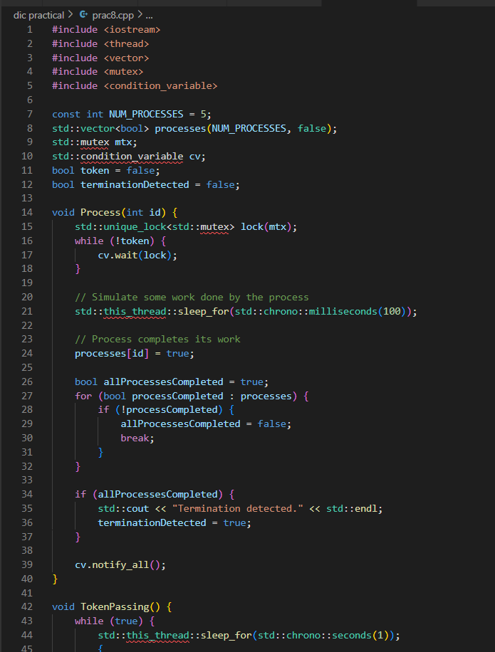

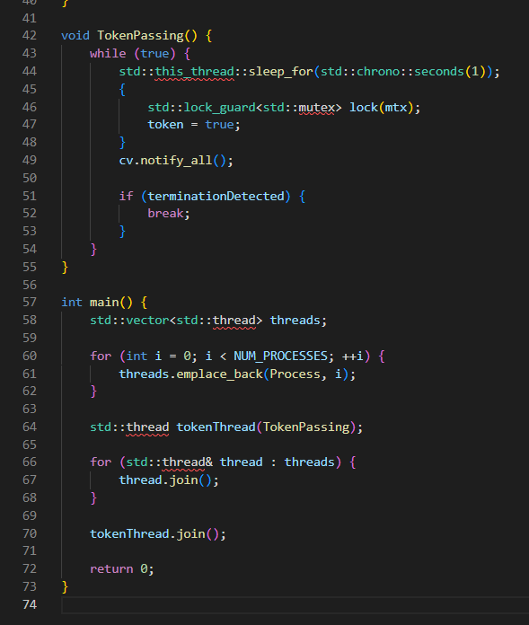

**OUTPUT:**



**_____________________________________________________________________________________**